**Web Programming**

**(LAB Session -05)**

**Adding CSS to your plain HTML Website**

**1.You need to apply CSS styling to the static website that you have developed in LAB-4. You have some UI requirement for the website as below.**

**Q-A) All the text should be in Arial black font with font size 12.**



**. p{font-size: 12px;**

**font-family: arial-black;}**

**Q- B) All the headings should be in times new roman font with font size 18.**



**.H1{font-size: 18px;**

**font-family: 'Times New Roman', Times, serif;}**

**Q-C) All the hyperlinks fonts should be bold and the background of the hyperlink should be yellow with red colour font if users move the mouse cursor over the link. Visited hyperlinks should be red coloured.**

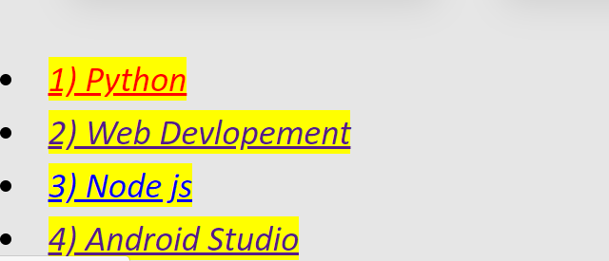

a{

  font: bold;

  background-color: yellow;

}

a:hover{

background-color: red;

}

a:visited{

background-color: red;

}

**Q-D) All the list item fonts should be italic**



li {

  font-style: italic;

}

**Q- E) In registration page, when user clicks on any checkbox or radio button, the selected item should have yellow background**

**.**table input[type="radio"]:checked+label,

.table input[type="checkbox"]:checked+label{

background-color:yellow;

}

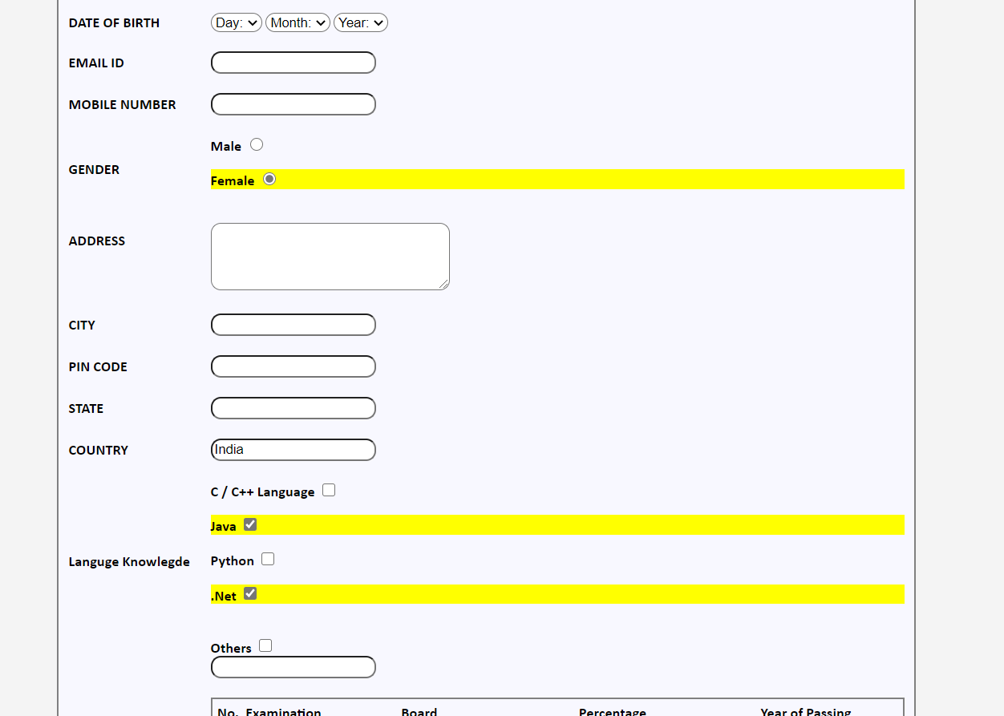

**Q-F) All five pages of the website should have a background created with gradient of one or more colours**

Body{

background:  linear-gradient(to top right,#cee9f1 0%,#f8eb786e 100%);

}



**Q-G) The background colour of menu bar at the top and marquee text line at the bottom should be properly selected so that it goes well with the background colour of the page**

<div class="link">

  <marquee style="font-size: 20px; background-color: rgb(205, 90, 90);" behavior="alternate"><a href="http://www.innovationclub.com/" >Innovation Club</a></marquee>

</div>

.link a:hover{

  color: red;

  background-color: yellow;

}

.link a:visited{

  color: red;

  background-color: yellow;

}

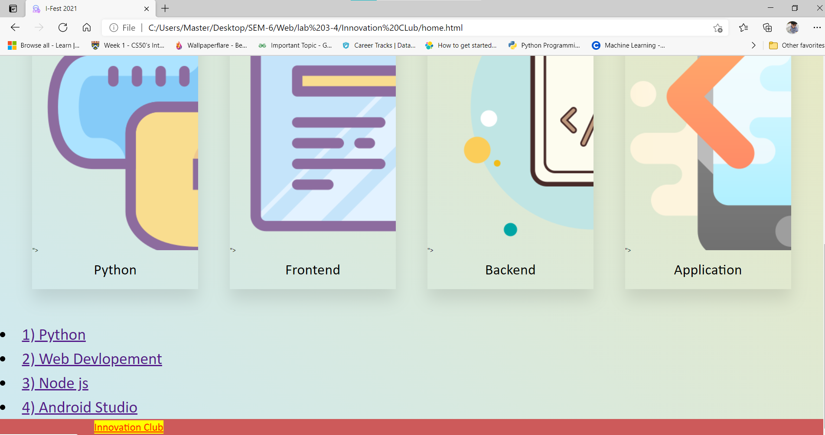

**Q- H) If user opens the website in mobile (screen width is 500px or less), the website should be open with a single-color background in all five pages instead of gradient background**

@media only screen and (max-width: 500px) {

  body {

      background-color:#e6e6e6;

  }

}

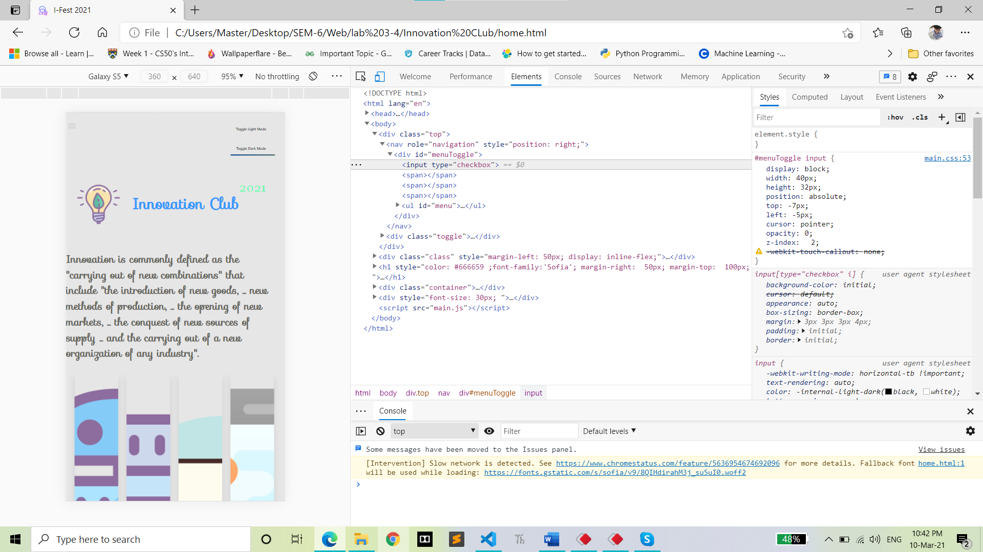

**Q- I) When user moves mouse over menus like Home, Cultural Event, Sport Event, Technical Event and Registration, the background colour of those menu text should be changed, font size should increase to 120% and font should become bold**

#menuToggle a:hover

{

  color: tomato;

  font-size: 120%;

}

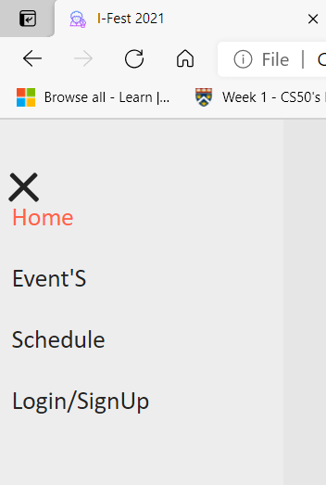

**Q- J) The first line of all the paragraphs should be indented.**



P{

text-indent: 25px;

}